Kubernetes

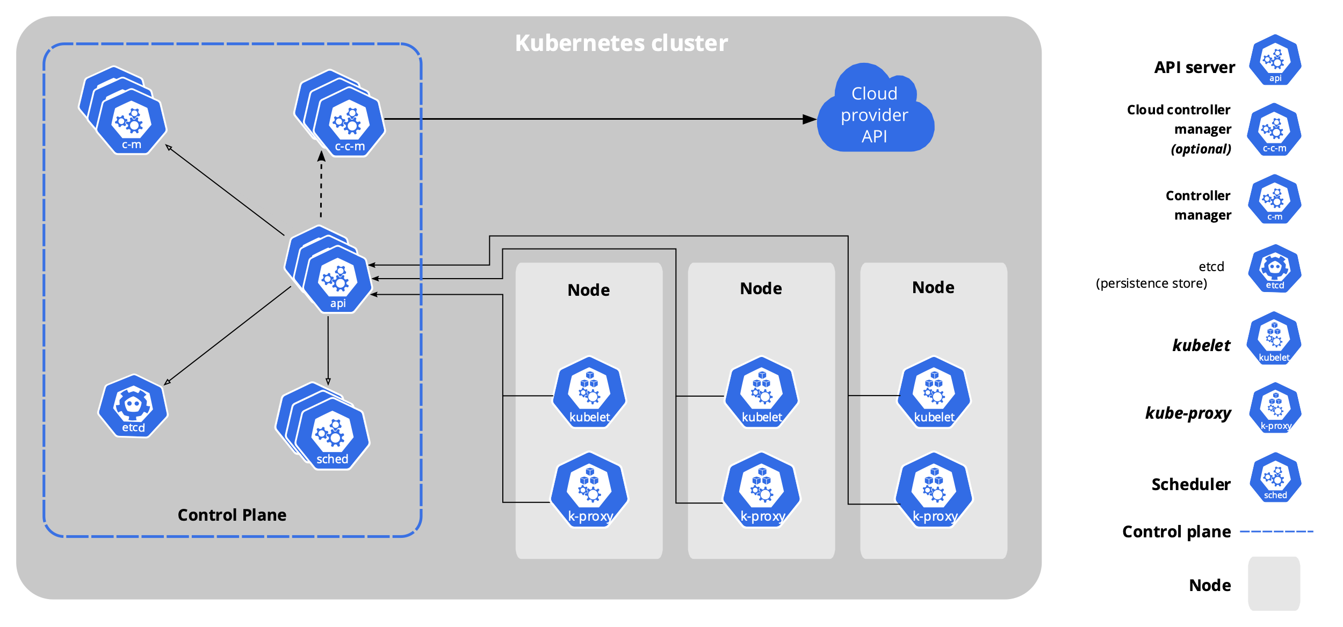

# Cluster Setup

## Set Hostname

Master Node:

sudo hostnamectl set-hostname master.example.com

exec bash

 Worker1 Node:

sudo hostnamectl set-hostname worker-node-1.example.com

exec bash

 Worker2 Node:

sudo hostnamectl set-hostname worker-node-2.example.com

exec bash

## Master Node initialisation

  sudo kubeadm init --pod-network-cidr=192.168.0.0/16

* TODO:  Copy kubeadm join command

  mkdir -p $HOME/.kube

  sudo cp -i /etc/kubernetes/admin.conf $HOME/.kube/config

  sudo chown $(id -u):$(id -g) $HOME/.kube/config

Install Container Network Interface (**CNI**)

  kubectl apply -f https://github.com/weaveworks/weave/releases/download/v2.8.1/weave-daemonset-k8s.yaml

Verification:

kubectl get nodes

NAME     STATUS   ROLES                  AGE   VERSION

master   Ready    control-plane,master   64m   v1.23.4

## Worker Nodes initialization - Worker1 & 2

**DONT COPY AND PASTE:**

sudo kubeadm join <master-ip>:6443 --token <token> \

        --discovery-token-ca-cert-hash <cert-hash>

Note: In case you need to find your unique token, run the command sudo kubeadm token create --print-join-command

labsuser@master:~$ kubectl get nodes

NAME                        STATUS   ROLES                  AGE   VERSION

master                      Ready    control-plane,master   75m   v1.23.4

worker-node-1.example.com   Ready    <none>                 72s   v1.23.4

worker-node-2.example.com   Ready    <none>                 52s   v1.23.4

# Basic commands of Kubernetes

kubectl get nodes

kubectl get nodes -o wide

kubectl describe node <node-name>

kubectl run nginxpod --image=nginx --port 80

kubectl get pods

kubectl get pods -o wide

kubectl describe pod <pod-name>

kubectl delete pod <pod-name>

kubectl create deployment my-dep --image=nginx

kubectl create deployment multi-pod --image=nginx --replicas 5

kubectl get deployments

kubectl get pods

kubectl exec -it <pod-name> /bin/sh

kubectl scale deployment multi-pod --replicas 10

kubectl scale deployment multi-pod --replicas 1

kubectl expose deployment multi-pod --type NodePort --port 80

kubectl get service

curl http://localhost:<node-port>